Table of Contents
Introduction 2
Economic Impact 2
Industry Analysis 3
BAM Group N.V. 4
Arcadis N.V. 5
Aalberts N.V. 5
Heijmans N.V. 5
Cementir Holding N.V. 6
SIF Holding 7
Market Capitalization 8
Revenue 8
The Biggest challenges in the mentioned companies 9
Bibliography 9

Introduction
The construction industry plays a vital role in the European Union's economy, contributing significantly to its growth and development. Here are key statistics and data highlighting the importance of the construction sector in the EU:
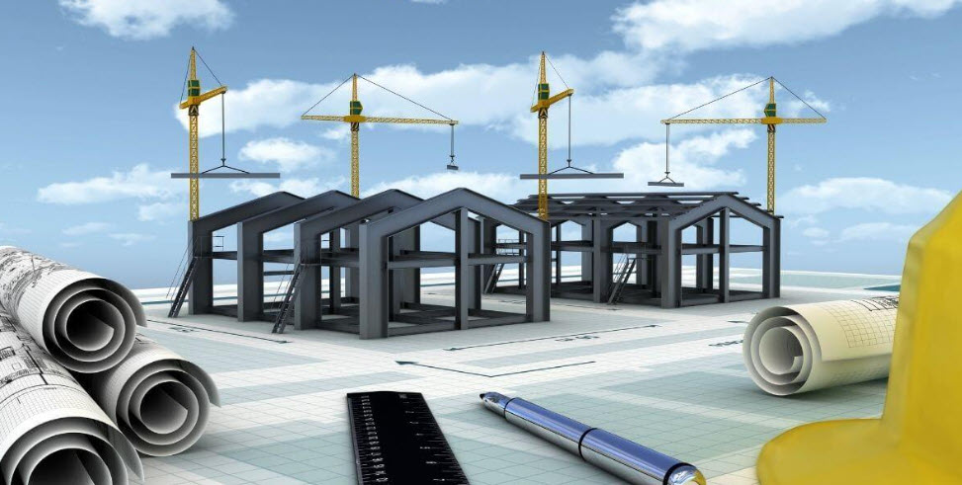

Economic Impact
The construction sector is a major contributor to the EU's economy:
- It generates about 9% of the EU's GDP (EBC, n.d.) (European Commission, n.d.).
- Construction is a significant source of employment in the EU. The sector provides 18 million direct jobs (European Commission, n.d.).
- The EU construction sector is characterized by a large number of small enterprises. There are more than 3 million enterprises in the construction sector (EBC, n.d.).
The construction sector in the EU is divided into three main activities:
- Specialised construction activities account for 59.0% of construction value added and 63.3% of employment (Construction, n.d.).
- Construction of buildings contributes 26.8% to the sector's value added (Construction, n.d.).
- Civil engineering makes up 14.2% of the construction total (Construction, n.d.).
The construction sector has faced challenges but shows signs of potential recovery:
- In 2023, the EU construction sector contracted by 2.3% (FIEC, n.d.).
- For 2024, a small decline in production volumes (-0.5%) is expected7 (Sante, 2024).
- A marginal increase of 0.5% in total EU construction volumes is projected for 2025 (Sante, ING, 2025).
Subsector Performance
Different subsectors within construction show varying trends:
The renovation subsector, including sustainability works, is experiencing structural growth in demand (Sante, ING, 2024).
Investments in infrastructure are expected to continue growing, driven by EU Recovery funds, digital infrastructure, and energy transition projects (Sante, ING, 2024).

Six major players in the construction industry in the world
- Vinci (France): The largest construction company globally, specializing in infrastructure development and urban transformation with operations in 120 countries. Known for projects like the Atlantic Bridge in Panama and a commitment to sustainable mobility and renewable energy. Market cap: US$62.53bn. (Wheeler, 2024)

- Larsen & Toubro (L&T) (India): A leading Indian engineering and construction powerhouse involved in infrastructure, power, defense, and IT sectors. Constructed India's longest sea bridge and contributes to the country's space program. Market cap: US$59.61bn. (Wheeler, 2024)

- D.R. Horton (USA): America's largest homebuilder by volume, with a focus on diverse housing across various price points, affordable housing, and the build-to-rent sector. Strengthened land development capabilities through the acquisition of Forestar Group. Market cap: US$44.52bn. (Wheeler, 2024)

- Lennar (USA): A major player in the U.S. homebuilding industry, delivering innovative housing solutions. Known for its "Everything's Included" approach, smart home technology, and sustainable building practices. Market cap: US$39.11bn. (Wheeler, 2024)

- China State Construction Engineering (CSCEC) (China): A significant global infrastructure company with projects like the Beijing National Stadium and the Burj Khalifa. Involved in developing eco-cities and smart urban complexes across China. Market cap: US$31.24bn. (Wheeler, 2024)

- Ferrovial (Spain): A global leader in infrastructure development and services, spanning transportation, urban mobility, and sustainable infrastructure. Notable achievements include the 407 ETR highway in Canada and London's Heathrow Airport management. Market cap: US$28.54bn. (Wheeler, 2024)

Six major players in the construction industry in the Netherlands
Based on the most recent data available from the search results, here are the market capitalizations for the six Dutch companies:
- Royal BAM Group N.V.: €1.29 billion (MarketScreener, 2025)
- Aalberts N.V.: €3.74 billion (Stock Analysis, 2025)
- Arcadis N.V.: €5.01 billion (Stock Analysis, 2025)
- Heijmans N.V.: €930.86 million (Stock Analysis, 2025)
- Cementir Holding N.V.: €1.98 billion (Stock Analysis, 2025)
- SIF Holding N.V.: €328.77 million (Stock Analysis, 2025)

Chart 1: Company Capitalizations

Industry Analysis
Six key players in the construction industry in the Netherlands:
Company | Primary Activities | Recent Innovations | Main Issue
BAM Group N.V. | - Construction and property development  - Civil engineering  - Public-private partnerships | - Opened a production facility for sustainable wooden Flow homes.  - Developed hydrogen as an alternative to diesel on construction sites (Element One project).  - Focused on energy transition and rail infrastructure markets (MarketScreener, 2025) | Regulatory hurdles, land scarcity, and network congestion impacting project execution and expansion (BAM, 2025)
Arcadis N.V. | - Architecture and engineering design  - Construction consultancy | - Implemented AI and data analytics for asset optimization.  - Expanded technology-enabled solutions for the asset lifecycle.  - Enhanced digital product offerings for efficiency savings (arcadis, 2023) | Adapting to stricter environmental regulations and managing operational costs amid sustainability demands (arcadis, 2023)
Aalberts N.V. | - Manufacturing mission-critical technologies  - Surface and heat treatments | - Invested in electrically powered multifunctional furnaces.  - Developed mechatronic systems for high-end machines.  - Focused on ultra-high purity liquid and gas supply systems for semiconductors (Aalberts, n.d.) | Declining revenue in cyclical segments, high material costs, and undervaluation of stock price (Aalberts, 2025)
Heijmans N.V. | - Property development  - Residential and non-residential building  - Infrastructure development | - Adopted modular construction techniques.  - Reduced CO2 emissions by 30% (2024 vs. 2023) and aims for climate neutrality by 2040.  - Experimenting with rainwater reuse and energy management systems.  - Launched the BioBuddy biodiversity monitoring box.  - Improved safety strategies, reducing incident severity and frequency rates (heijmans, 2025) | Delays in permitting, housing market stagnation, and supply chain disruptions affecting project timelines (heijmans, 2025)
Cementir Holding N.V. | - Cement production  - Ready-mixed concrete manufacturing  - Aggregates processing  - Waste management | - Introduced FUTURECEM™ technology, reducing CO2 emissions by 30%.  - Expanded FUTURECEM™ to France and Benelux.  - Developed Ultra-High-Performance Concrete (UHPC) products.  - Implemented Cementir 4.0 digitalization project.  - Committed to a 30% CO2 reduction by 2030 with €107 million in sustainability projects.  - Collaborated on CALLISTE research for further CO2 reductions (cementirholding, 2023) | Delays in permitting, housing market stagnation, and supply chain disruptions affecting project timelines (think.ing, 2024)
SIF Holding | - Offshore wind turbine monopile manufacturing  - Transition pieces and pin-piles | - Built the world’s largest monopile manufacturing plant in Rotterdam (€328 million investment).  - Increased production capacity to 500 kilotons/year.  - Developed XXXL monopiles (up to 11.5m diameter, 2,500 tons).  - Improved sustainability through electrification of production processes.  - Innovated technologies like Skybox for TP-Less foundations and green steel transition.  - Produced first monopile at expanded Maasvlakte II plant in late 2024 (Sif, n.d.) | Dependence on offshore wind market growth while managing supply chain and production efficiency issues (Sif, n.d.)
Table 1: Six key industry players

BAM Group N.V.
Primary Activities:
- Construction and property development
- Civil engineering
- Public-private partnerships
Recent Innovations:
- Opening of a production facility for sustainable wooden Flow homes concept.
- Development of hydrogen as an alternative to diesel on construction sites through the 'Element One' project.
- Focus on energy transition and rail infrastructure markets (MarketScreener, 2025).

Arcadis N.V.
Primary Activities:
- Architecture and engineering design
- Construction consultancy
Recent Innovations:
- Implementation of AI and data analytics to help clients repurpose and improve assets.
- Development of technology-enabled solutions across the entire asset lifecycle.
- Expansion of digital products offering for asset optimization and efficiency savings (arcadis, 2023).

Aalberts N.V.
Primary Activities:
- Manufacturing of mission-critical technologies
- Surface treatments and heat treatments
Recent Innovations:
- Investment in electrically powered multifunctional furnaces for surface technologies.
- Development of mechatronic systems and motion and fluid control for high-end machines.
- Focus on ultra-high purity liquid and gas supply systems for the semiconductor industry (Aalberts, n.d.).

Heijmans N.V.
Heijmans NV is a major Dutch construction company with a focus on creating healthy living environments.
Primary activities:
- Property development
- Residential building
- Non-residential building
- Infrastructure development
Recent innovations:
- Modular construction: Heijmans is implementing prefabrication techniques for finishing and technical installations in data center projects, improving efficiency and reducing on-site construction time (heijmans, 2025).
- Sustainability initiatives: The company aims to make its operations and supply chain climate-neutral by 2040. In 2024, they reduced Scope 1 and 2 CO2e emissions by 30% compared to 2023.
- Water management: Heijmans is experimenting with rainwater reuse in residential construction sites to reduce household water consumption.
- Energy solutions: The company is testing an energy management system in the Waterviolier district of Nuenen to optimize locally generated energy use.
- Safety improvements: Heijmans has implemented a new safety strategy focusing on High-Risk Activities (HRA), resulting in a decrease in the severity of incidents and a reduction in the Incident Frequency (IF) rate from 3.1 to 2.3.
- Biodiversity monitoring: Heijmans launched the BioBuddy, an innovative biodiversity monitoring box.
Heijmans reported strong financial performance in 2024 and has a positive outlook for 2025, expecting revenue to increase to €2.75 billion and a minimum underlying EBITDA margin of 8.0% (MarketScreener, 2025).

Cementir Holding N.V.
Cementir Holding N.V. is a multinational company operating in the building materials sector, with a focus on cement production and related activities.
Primary Activities:
- Cement production (grey and white cement)
- Ready-mixed concrete manufacturing
- Aggregates extraction and processing
- Waste management and alternative fuel production
Recent Innovations:
- FUTURECEM™ Technology: A patented cement technology that allows for more than 35% clinker substitution with limestone and calcined clay, reducing CO2 emissions by up to 30% compared to ordinary Portland cement (cementirholding, 2023).
- Expansion of FUTURECEM™: Launched in France and Benelux markets in 2022, following its introduction in Denmark in 2021 (cementirholding, 2023).
- InWhite® Solutions: Development of Ultra-High-Performance Concrete (UHPC) products using FUTURECEM™ technology, including Aalborg Extreme® and Aalborg Excel® (cementirholding, 2023).
- Cementir 4.0 Project: Implementation of digital technology throughout the production process to enhance operational excellence and reduce environmental impact (worldcement, 2022).
- Sustainability Initiatives: Commitment to reduce CO2 emissions by 30% by 2030, with a €107 million investment plan in sustainability projects.
- CALLISTE Research Initiative: Collaboration with the Danish Technological Institute to further develop FUTURECEM™ technology, aiming for a 50% CO2 reduction compared to conventional Portland cement by the end of 2024.
- Product Innovation: Development of high added-value and technologically advanced white cement-based solutions through the Aalborg InWhite Solution™ platform (cementirholding, n.d.).
These innovations demonstrate Cementir's focus on sustainability, digitalization, and product development to maintain its position as a leader in the cement industry, particularly in the white cement segment.

SIF Holding
SIF Holding is a leading manufacturer of monopile foundations for the offshore wind energy industry.
Primary Activities:
- Manufacturing of monopile foundations for offshore wind turbines
- Production of transition pieces and pin-piles/jacket legs
- Providing solutions for the offshore wind energy sector
Recent Innovations:
- Construction of World's Largest Monopile Manufacturing Plant: In February 2023, SIF announced a €328 million investment to build the world's largest monopile foundation manufacturing plant in Rotterdam, Netherlands.
- Increased Production Capacity: The new facility at Maasvlakte II in Rotterdam has significantly increased SIF's total combined capacity to 500 kilotons a year.
- XXXL Monopile Production: The upgraded manufacturing plant enables SIF to produce 200 XXXL monopiles annually, with diameters up to 11.5 meters and weighing up to 2,500 tons each.
- Sustainability Improvements: The new facility features higher electrification of production and transport equipment, resulting in lower nitrogen emission and deposition levels compared to previous operational standards.
- Advanced Manufacturing Technology: SIF has implemented next-level integrated manufacturing technology with improved process and quality controls.
- Product Innovation: The company is developing technologies such as the Skybox, which accelerates the installation of TP-Less foundations and simplifies monopiles.
- Research and Development: SIF is working on various innovations including low-noise pile-driving, alternative fixed seabed foundations for deeper waters, and the transition to green steel.
- First Monopile Production: In late 2024, SIF successfully manufactured the first monopile at its expanded Maasvlakte II plant, marking a significant milestone in its innovation journey (EGERIA, 2023).
These innovations have positioned SIF Holding as a critical supplier in the offshore wind value chain, with a strong focus on meeting the growing demand for larger capacity turbines and next-generation 3XL monopile foundations (Sif, n.d.).
Market Capitalization Revenue
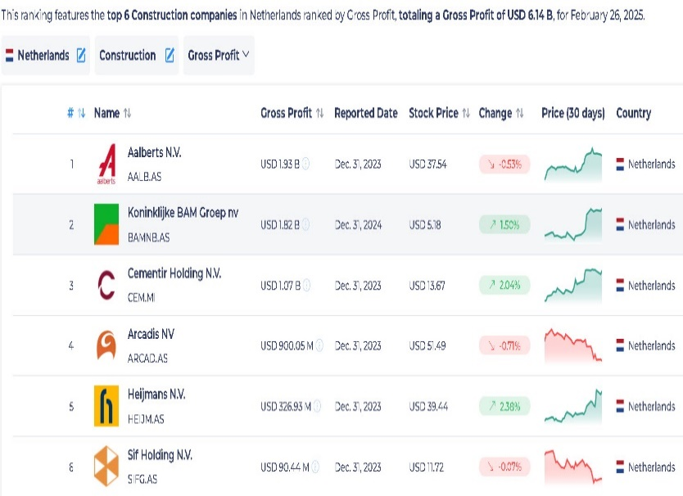  Image1: Market Capitalization (StockViz, 2025) | 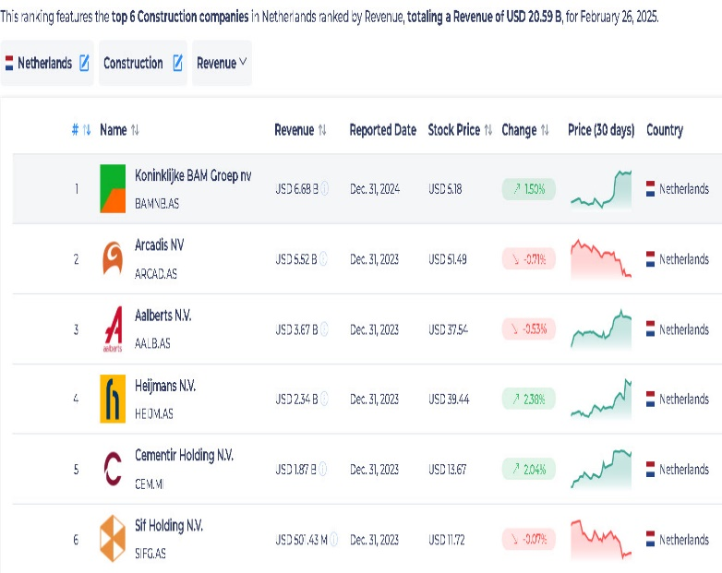  Image2: Revenue (StockViz, 2025)

The Biggest challenges in the mentioned companies
Company | Biggest Challenges
BAM Group N.V. | - Attracting and retaining skilled employees.  - Uncertainty regarding interest rates, Dutch nitrogen regulations, and political unrest.  - Supply chain issues and project delays in construction markets, particularly in the UK (BAM, 2025)
Arcadis N.V. | - Rising costs of implementing digital and AI technologies.  - Managing workforce transitions to adopt new technology.  - Balancing sustainability goals with client demands for cost efficiency (arcadis, 2023)
Aalberts N.V. | - Skilled labor shortages, particularly engineers, impacting innovation.  - High raw material costs and inflation affecting profitability.  - Low productivity growth in European machinery market (Aalberts, 2025)
Heijmans N.V. | - Regulatory challenges with stricter sustainability standards.  - Rising material costs due to inflation.  - Delays in project completions caused by supply chain disruptions.  - High costs of transitioning to emission-free construction (heijmans.nl, n.d.)
Cementir Holding N.V. | - High investment requirements for sustainability projects (e.g., FUTURECEM™ expansion).  - Balancing CO2 reduction targets with operational efficiency.  - Competition in the cement market for low-emission products (cementirholding, 2023)
SIF Holding | - Managing high capital investments (€328 million) for new facilities.  - Transitioning to green steel and low-noise pile-driving technologies.  - Adapting to stricter sustainability regulations while maintaining profitability (Sif, n.d.)

Three selected companies
Based on the search results, I'll focus on three prominent construction companies in the Netherlands based on the GDP.
1. Aalberts N.V.
- Why this company? Aalberts N.V. is chosen because it has the highest gross profit among construction companies in the Netherlands, at USD 1.93 billion. This indicates a strong financial performance and significant market presence. Also, with its focus on surface and heat treatments, Aalberts is essential in the construction sector. (Aalberts, 2025)

- What is the main issue in this company? According to my research, the primary challenges for Aalberts N.V. are "Declining revenue in cyclical segments, high material costs, and undervaluation of stock price". (Aalberts, 2025)

- How can we address the issue? Mitigation strategies include:
- Diversification into Growth Markets: Target expansion into sectors with strong growth potential, such as sustainable infrastructure and renewable energy, to offset revenue declines in cyclical segments.
- Cost Optimization: Implement rigorous cost management strategies to mitigate the impact of high material costs and improve profitability.
- Investor Relations and Value Communication: Proactively communicate the company's strategic initiatives and long-term value proposition to investors to address the undervaluation of the stock price. (Aalberts, 2025)
2. Koninklijke BAM Groep nv (Royal BAM Group N.V.)

- Why this company? Royal BAM Group N.V. is included because it is among the top companies with a strong gross profit in the construction and property development business. (BAM, 2025)

- What is the main issue in this company? The main challenges for Royal BAM Group N.V. revolve around "Regulatory hurdles, land scarcity, and network congestion impacting project execution and expansion”. (BAM, 2025)

- How can we address the issue? Strategies to overcome these challenges involve:
- Strengthened Stakeholder Engagement: Engage with regulatory bodies to streamline approval processes and reduce delays in project execution.
- Optimized Supply Chain Management: Enhance supply chain management practices to minimize disruptions and ensure timely project completion. (BAM, 2025)
3. Heijmans N.V.
- Why this company? The high gross profit makes Heijmans N.V a top company in the construction sector. (heijmans, 2025)

- What is the main issue in this company? The main challenges for Heijmans include "rising material costs, regulatory changes (particularly regarding nitrogen emissions), and maintaining affordability while transitioning to more sustainable practices". (heijmans, 2025)

- How can we address the issue? To address these issues, Heijmans can:
- Invest in modular and industrial construction techniques to improve efficiency and affordability.
- Collaborate with policymakers to streamline permitting processes, especially regarding environmental regulations.
- Focus on sustainable housing solutions and energy transition projects to align with regulations and market demands. (heijmans, 2025)

Bibliography
Aalberts. (n.d.). Retrieved from https://aalberts.com/sustainability
Aalberts. (2025, February 27). Retrieved from Aalberts delivers resilient performance in challenging markets: https://aalberts-website.s3.eu-west-1.amazonaws.com/media/App/Models/Download/000/000/493/attachment/original/FY2024.pdf
arcadis. (2023). Retrieved from https://www.arcadis.com/en/news/global/2023/11/arcadis-presents-its-2024-2026-strategy-accelerating-a-planet-positive-future
ARCADIS. (2025, February). Retrieved from Arcadis Fourth Quarter and Full Year Results 2024: https://www.arcadis.com/en/news/global/2025/2/arcadis-fourth-quarter-and-full-year-results-2024
bam. (n.d.). Retrieved from Building a sustainable tomorrow: https://www.bam.com/en/about-bam/strategy
BAM. (2025, February 13). Retrieved from https://www.bam.com/sites/bamc/files/2025-02/bam-2025-02-13-q4-2024-en-press-release.pdf
cementirholding. (n.d.). Retrieved from Product innovation: https://www.cementirholding.com/en/our-business/innovation/product-innovation
cementirholding. (2023). Retrieved from cementirholding annual report: https://aalborgportlandholding.com/sites/default/files/documenti/2024-09/Cementir%20Holding%20Annual%20Report%202023.pdf
CFA institite. (n.d.). Retrieved from CFA institite: https://cfasociety.nl/uploads/2024/20240301%20research%20challenge/Aalberts%20CFA%20Research%20Challenge%20-%20FM1%20Uttrecht.pdf
Construction. (n.d.). Retrieved from ec.europa.eu: https://ec.europa.eu/eurostat/cache/htmlpub/key-figures-on-european-business-2022/construction.html
EBC. (n.d.). Retrieved from Representing construction SMEs & craftsmen in Europe: https://www.ebc-construction.eu/about-us/facts-figures/
EGERIA. (2023). Retrieved from https://egeriagroup.com/news/sif-takes-final-investment-decision-to-construct-the-worlds-largest-monopile-foundation-manufacturing-plant/
European Commission. (n.d.). Retrieved from Construction sector: https://single-market-economy.ec.europa.eu/sectors/construction_en
FIEC. (n.d.). Retrieved from Overall construction activity: https://fiec-statistical-report.eu/european-union
Gerrand, N. (2024, June). constructionbriefing. Retrieved from The European construction industry in 4 charts: https://www.constructionbriefing.com/news/the-european-construction-industry-in-4-charts/8037704.article
heijmans. (2025, February). Retrieved from https://www.heijmans.nl/en/news/heijmans-to-use-innovations-in-construction-of-new-data-centre/
heijmans.nl. (n.d.). Retrieved from On the way to emission-free construction: https://www.heijmans.nl/en/stories/on-the-way-to-emission-free-construction/
MarketScreener. (2025). Retrieved from https://www.marketscreener.com/quote/stock/ROYAL-BAM-GROUP-N-V-6378/news/Royal-BAM-N-Press-release-bam-2025-02-13-q4-2024-en-press-release-49049993/
MarketScreener. (2025). Retrieved from https://www.marketscreener.com/quote/stock/KONINKLIJKE-HEIJMANS-N-V-6409/news/Royal-Heijmans-strong-year-and-positive-outlook-for-2025-49121833/
Sante, M. v. (2024, March 18). ING. Retrieved from EU construction sector faces year of decline but green shoots appear: https://think.ing.com/articles/eu-construction-sector-faces-year-of-decline-but-green-shoots-appear/
Sante, M. v. (2024, March 18). ING. Retrieved from EU construction sector faces year of decline but green shoots appear: https://think.ing.com/articles/eu-construction-sector-faces-year-of-decline-but-green-shoots-appear/
Sante, M. v. (2025, January 21). ING. Retrieved from Growth returns to Europe’s construction sector: https://think.ing.com/articles/returning-but-low-growth-expected-in-the-european-construction-sector/
Sif. (n.d.). Retrieved from Product innovation at Sif: https://sif-group.com/en/product-innovation/
StockViz. (2025, February). Retrieved from Top Construction companies in Netherlands by Gross Profit: https://stockviz.com/en/ranking-of-netherlands-stocks-in-construction-by-gross-profit
worldcement. (2022, March). Retrieved from Cementir Group launches FUTURECEM in France and Benelux: https://www.worldcement.com/europe-cis/02032022/cementir-group-launches-futurecem-in-france-and-benelux/

